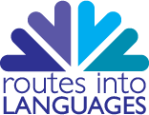

Routes into Languages
Conference

Working together for languages in schools and universities

Thursday 28 January 2016
British Medical Association
BMA House - Tavistock Square - London - WC1H 9JP

Dear colleagues,

I am delighted to welcome you to our celebratory event ‘Routes into Languages: Working together for languages in schools and universities’.
The event will enable you to meet a wide range of partners, learn more about the achievements of Routes colleagues over the past two years, and see examples of exciting projects from around the country.
We will hear from some guest speakers, including Sir David Bell, who chairs the Routes Steering group for HEFCE, and we will share examples of good practice. During the day you will learn more about the directions we are planning for the future, after the HEFCE funding ends in July.
May I take this opportunity to thank you for attending today’s event. I hope you will find the day useful to you and we shall look forward to seeing you at future events.
All best wishes,
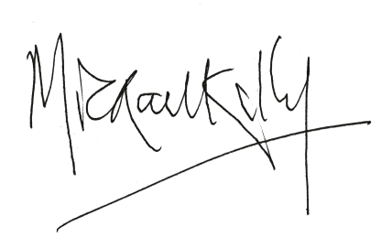
Prof. Mike Kelly
National Director of Routes into Languages

Conference programme
am
9.50-10.20 | Coffee and registration
10.20-10.30 | Paget Room  Welcome and housekeeping
10.30-11.00  Keynote 1 | Paget Room  Sir David Bell (Chair of Routes Steering Group and VC University of Reading)  Routes into Languages: looking back and looking forward
11.00-11.30  Keynote 2 | Paget Room  Jocelyn Wyburd (Chair of Routes Advisory Board and Chair of UCML)  New qualifications: implications for Routes partners
11.30-11.50 | Coffee
11.50-12.40  Parallel session 1 | Paget Room  Routes South West – Robert Vilain (University of Bristol) & Fiona Malkin (Nailsea School)  The Upfest / Berlin Wall project and the MOOC "Cultural Studies and Modern Languages"  Routes South East – Catherine Watts (University of Brighton) & Katrin Kohl (University of Oxford)  Oxford German Olympiad | Murrell Room  Routes North West – Yasmin Hussain (Manchester Metropolitan University)  Mother Tongue Other Tongue Poetry Competition - Using Languages to Promote Creativity, Diversity and Inclusion  Routes West Midlands – Claire Girle & Hina Khan (Aston University)  Joseph Chamberlain College Language and Culture Tutors Scheme
12.45-13.45 | Lunch

Conference programme
pm
13.45-14.15 Keynote 3 | Paget Room  Anne-Marie Graham (UK HE International Unit)  Going, Going, Gone International – encouraging more UK students to access an international experience
14.15-15.05  Parallel session 2 | Paget Room  Routes Yorkshire & Humber – Claire Barber (University of Hull)  Languages and Design Competition and Languages through Science  Routes London – Renata Albuquerque (SOAS) & Debra Kelly (University of Westminster)  Bridges and Stepping Stones: transitions in languages teaching and learning | Murrell Room  Routes North East – Liz Andersen & Sophie Stewart with Student Ambassadors Liam Innis & Ruta Vaiciute (Newcastle University)  Leading the Way: The Senior Student Language Ambassador Team  Routes East – Kim Ridealgh (University of East Anglia) & Sarah Schechter (Anglia Ruskin University)  Coca Cola Language Business Enterprise Project and beyond
15.05-15.20 | Tea
15.20-15.45  Parallel session 3 | Paget Room  National Network for Translation & National Network for Interpretation  Myriam Salama-Carr (University of Manchester)  The networks for translation and interpreting: taking stock and planning the future | Murrell Room  Routes East Midlands – Estefania Escobar Salazar (Nottingham Trent University) & James Philip Hewlett (Translator/ Reviser – ex University of Nottingham)  Routes into Languages in the East Midlands
15.45 -16.15  Keynote 4 | Paget Room  Jane Driver (The Voyager School)  Linking Active Participation to Long-term Motivation
16.15 | Finish

